Welcome to Share Discovery Village. We are committed to making our site, activities, accommodation, and facilities as accessible and inclusive as possible for all guests, visitors, carers, families, schools, and groups.
This booklet has been created to help guests plan their visit and understand the accessibility support available across the site.

Contents
- About Share Discovery Village
- Before You Arrive
- Arrival & Parking
- Reception & Check-In
- Accommodation Accessibility
- Activity Accessibility
- Water-Based Activities
- Dining & Catering
- Toilets & Changing Facilities
- Sensory & Quiet Spaces
- Mobility & Site Navigation
- Medical & Additional Support
- Assistance Dogs
- Emergency Procedures
- Group Leaders & Schools
- Accessibility Contacts
- Feedback & Continuous Improvement

About Share Discovery Village
Share Discovery Village is an outdoor adventure and activity centre located in County Fermanagh, Northern Ireland. We are a NI registered charity set up in 1981 - the International Year of Disabled Persons. We wanted to create an accessible place for people with disabilities to go on their holidays with their family and friends. We welcome:
- Families
- Schools
- Youth groups
- Church groups
- Community groups
- Disability organisations
- Corporate groups
- Residential visitors
- Day visitors
We aim to provide meaningful and enjoyable experiences for everyone, regardless of age, ability, or support needs.

Before You Arrive
To help us support your visit, we encourage guests and group leaders to contact us before arrival to discuss:
- Mobility requirements
- Wheelchair accessibility
- Dietary requirements
- Sensory considerations
- Support staff or carers attending
- Activity suitability
- Accessible accommodation requests

Pre-Visit Information Available
We can provide:
- Photos of accommodation and facilities
- Site maps
- Activity information
- Risk assessments (where appropriate)
- Dietary guidance
- Arrival instructions
- Accessibility support discussions

Arrival & Parking

Accessible Parking
Accessible parking spaces are available close to key buildings and facilities.There is also car parking outside the chalets.
Parking areas:
- Are level or gently sloped where possible
- Include accessible routes to reception
- Have designated disabled parking bays

Drop-Off Areas
Groups and visitors may use designated drop-off points close to accommodation and reception buildings.

Pathways Around Site
Many pathways across the site are:
- Wide enough for wheelchair access
- Suitable for mobility aids
- Clearly signposted
Please note that some outdoor adventure areas may include:
- Uneven ground
- Gravel pathways
- Grass surfaces
- Slopes or inclines
We recommend contacting us in advance to discuss specific accessibility needs.

Reception & Check-In
Reception staff are available to assist guests during arrival and throughout their stay.
Support available includes:
- Check-in assistance
- Directions around site
- Activity information
- Emergency contact support
- Accessibility guidance

Reception Accessibility
Reception areas include:
- Step-free access
- Accessible entrance routes
- Seating area
- Clear signage
If additional support is required, staff will be happy to assist.

Accommodation Accessibility
Each of our chalets are fully accessible. We can provide a profiling bed, hoist and changing table in your chalet.
Features include:
- Ground floor access
- Accessible bathrooms
- Wider doorways
- Transfer space beside beds
- Lowered facilities
- Accessible parking nearby

Bedroom Information
- We can put up bunk beds if they are requested
Please contact us before booking so we can recommend the most suitable accommodation.

Hoists & Specialist Equipment
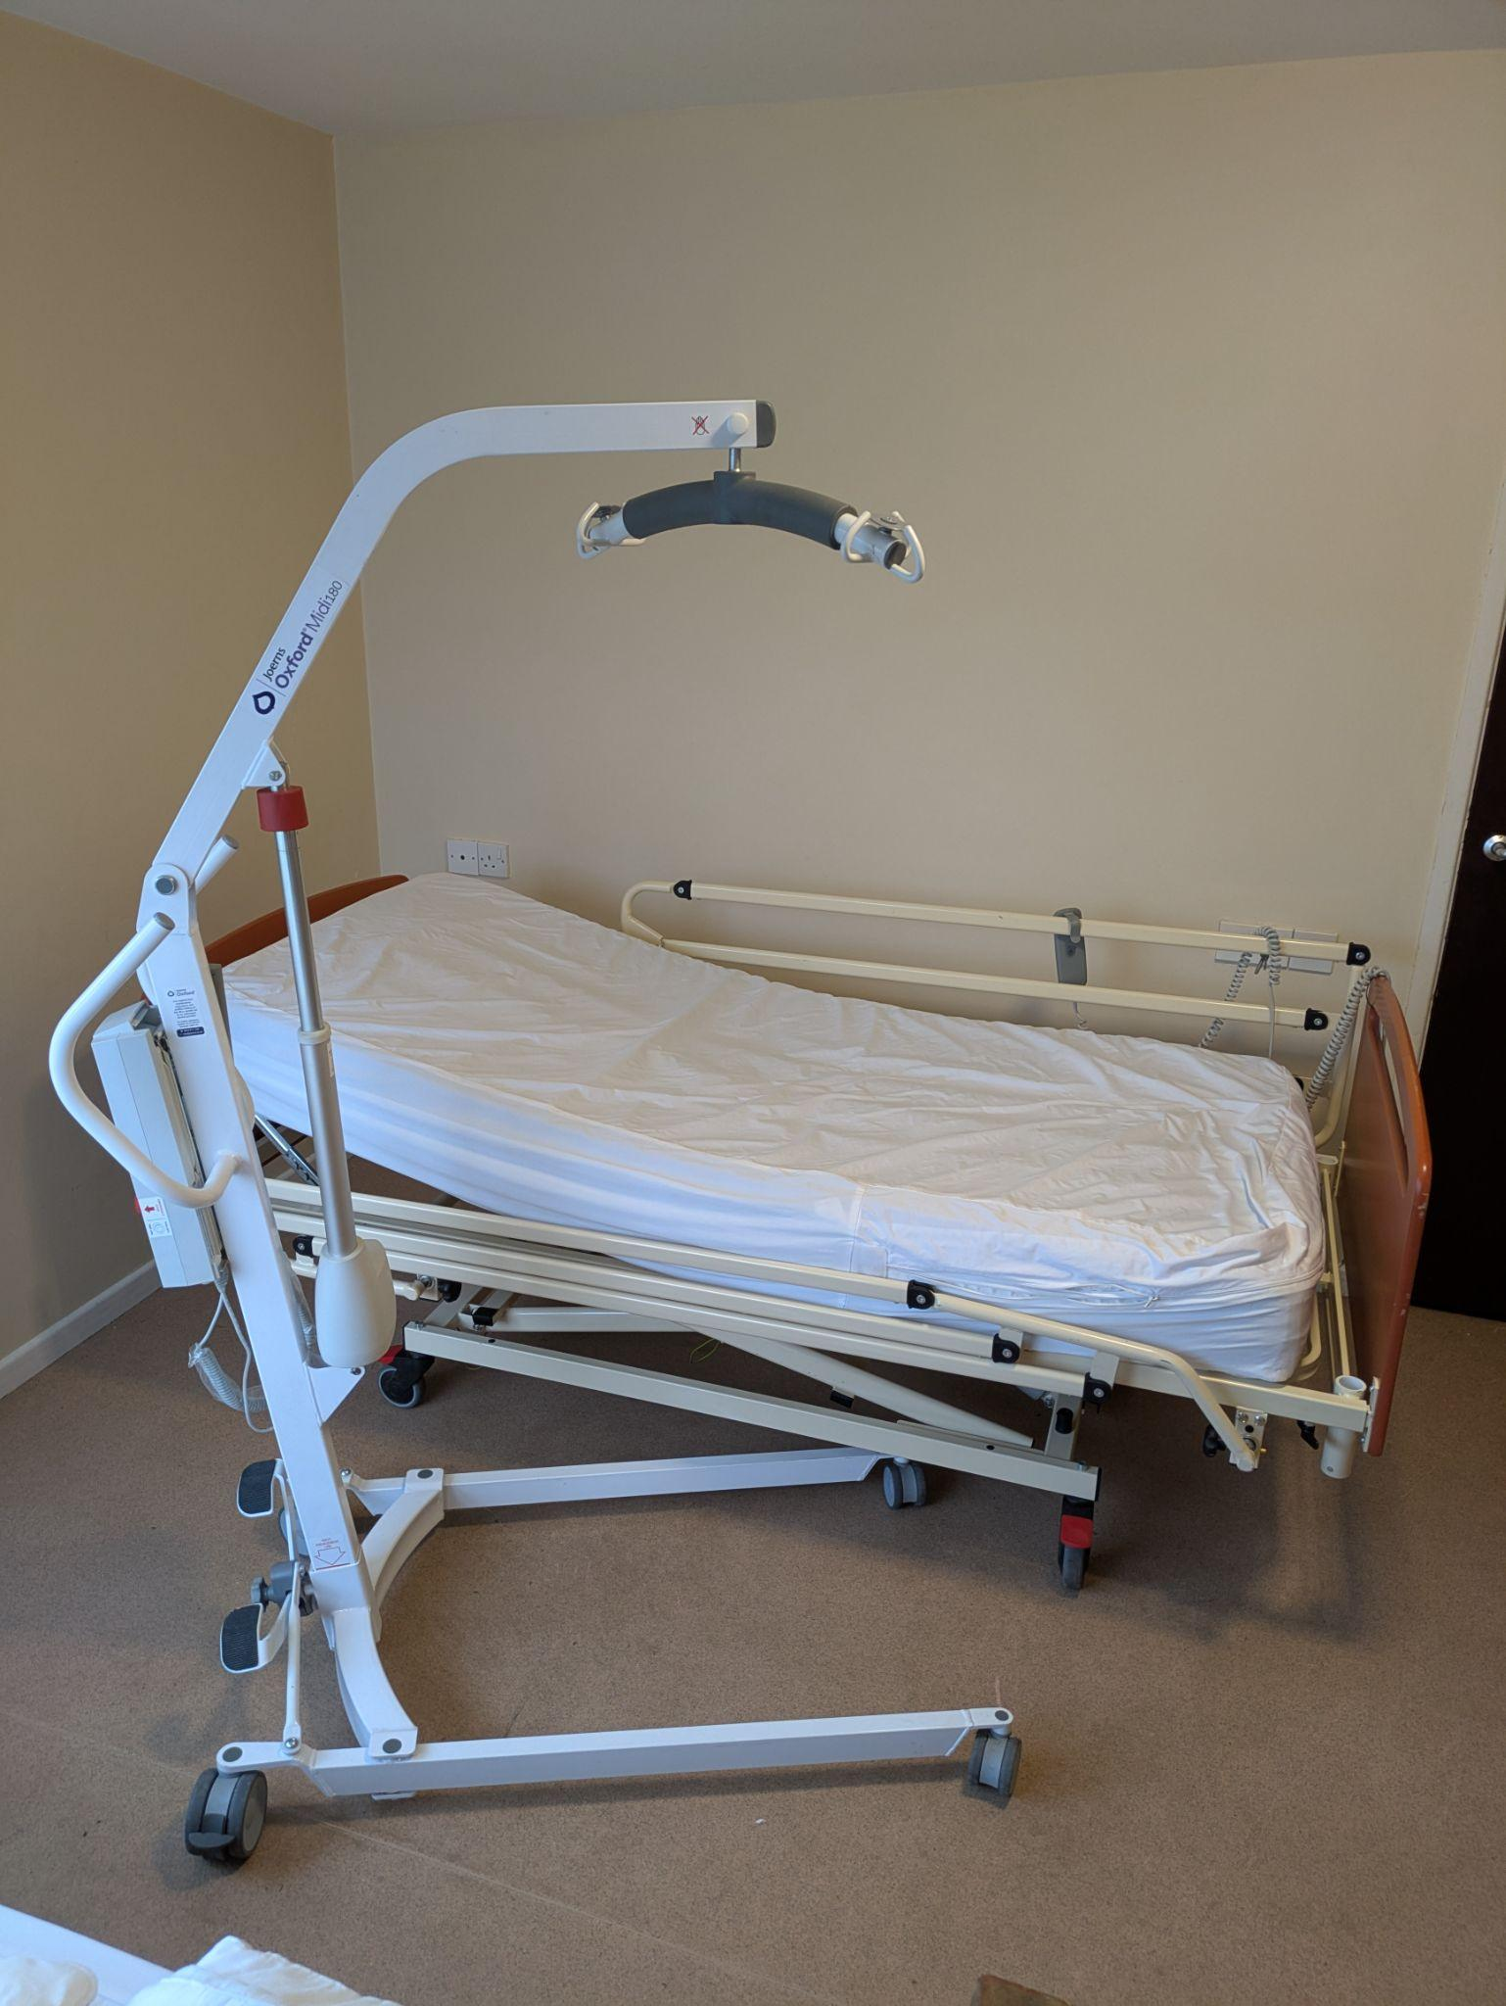
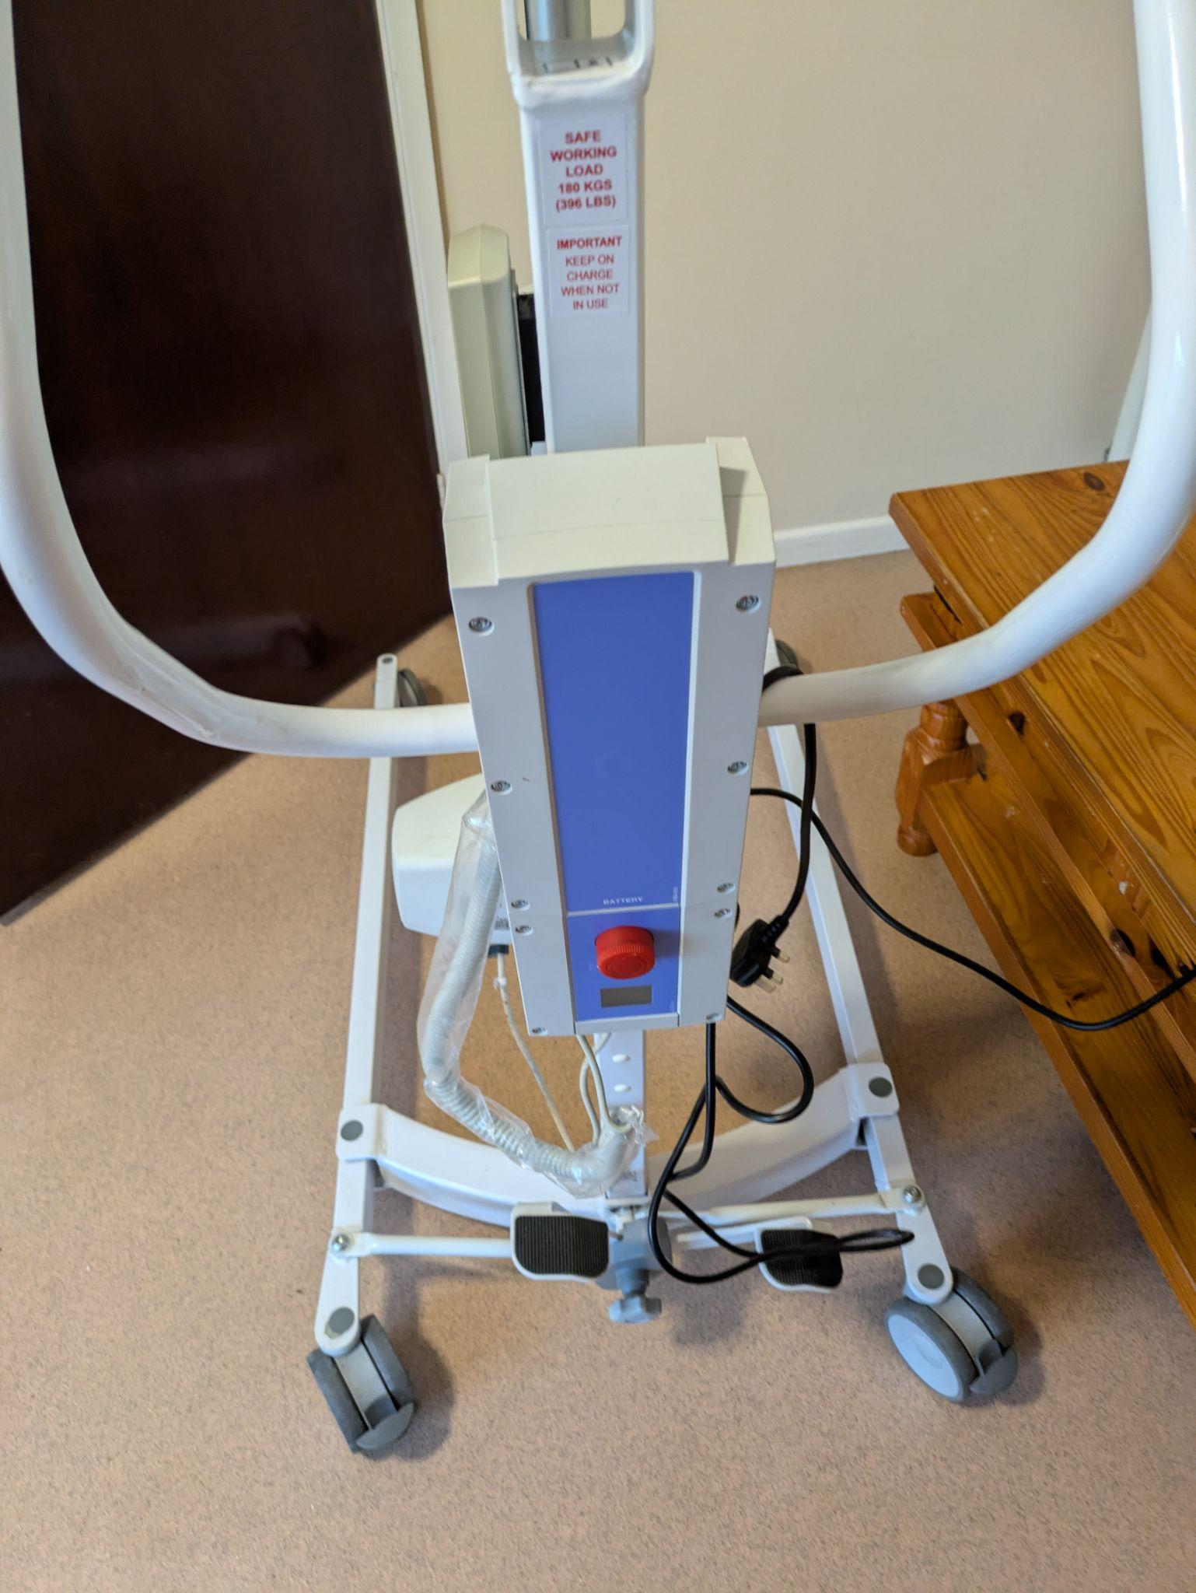
We can provide a profiling bed, hoist and changing table in your chalet. They can be reserved if you book a self catering chalet or requested when making group booking.

Activity Accessibility
We believe outdoor activities should be accessible to everyone wherever possible.
Activities may be adapted depending on:
- Individual ability
- Mobility requirements
- Confidence levels
- Medical considerations
- Weather conditions
- Staffing support

Activities
We offer a wide range of indoor and outdoor activities suitable for different ages and abilities. Activities available during your stay may include:
- Kayaking - Explore the water in specially adapted kayaks, with support available where required.
- Canoeing - Enjoy guided canoe sessions suitable for beginners and experienced guests.
- Stand Up Paddleboarding (SUP) - Develop balance and confidence on the water, with adaptive equipment available where appropriate.
- Towables - Experience exciting rides on inflatable towable crafts, pulled by a powerboat.
- Swimming Pool - Enjoy our swimming pool for recreational swimming and group sessions. The pool has ramps to ensure it is accessible to all.
- Climbing Wall - Challenge yourself on our climbing wall using accessible climbing equipment where required.
- Archery - Learn and practise archery skills in a safe and supervised environment.
- Combat Corps - Take part in team-based challenges and tactical games that encourage communication and problem-solving.
- Arts and Crafts Activities - Get creative with a variety of fun and engaging craft sessions.

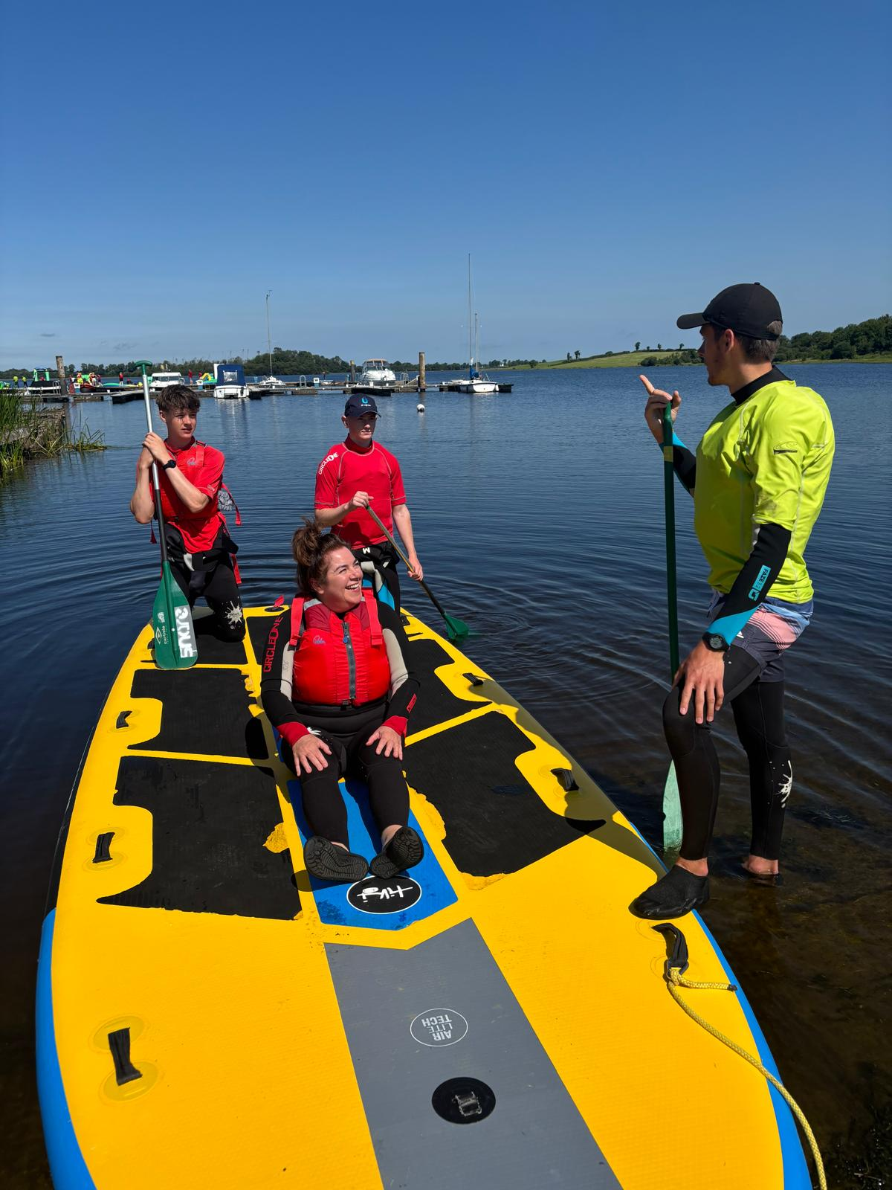
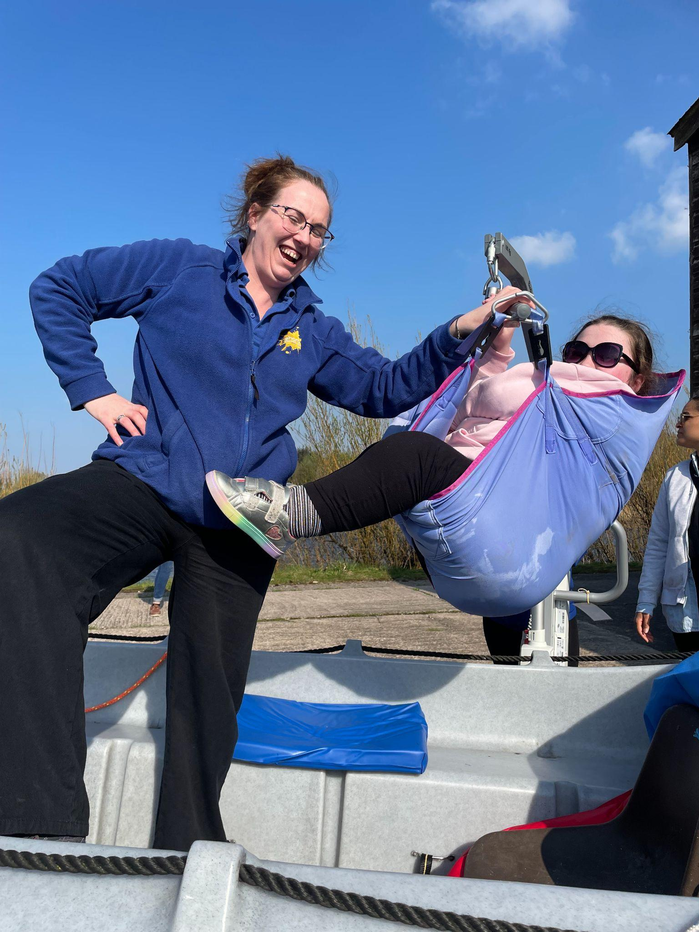
Please note: Activities offered may vary depending on the season, weather conditions, group requirements and instructor availability. We are committed to making our activities as inclusive as possible and encourage guests to discuss any accessibility requirements with us before their visit so that we can help provide the most suitable experience. We have accessible climbing equipment for our climbing wall. And for guests who require assistance, we can support transfers into our boats using a sling.

Inclusive Participation
Instructors aim to:
- Adapt communication styles
- Provide demonstrations
- Allow extra time
- Offer encouragement and reassurance
- Adjust activities where practical
Some activities may not be suitable for all participants due to safety requirements.
Water-Based Activities
Safety is our priority during all water-based activities.

Support Available
Depending on activity type and individual needs, support may include:
- Buoyancy aids
- Additional instructor support
- Gradual access into equipment

Important Information
Participants should inform staff about:
- Swimming ability
- Medical conditions
- Seizure conditions
- Sensory concerns
- Anxiety around water
Changing facilities may vary depending on the activity location.

Wheelchair Accessible Picnic Benches
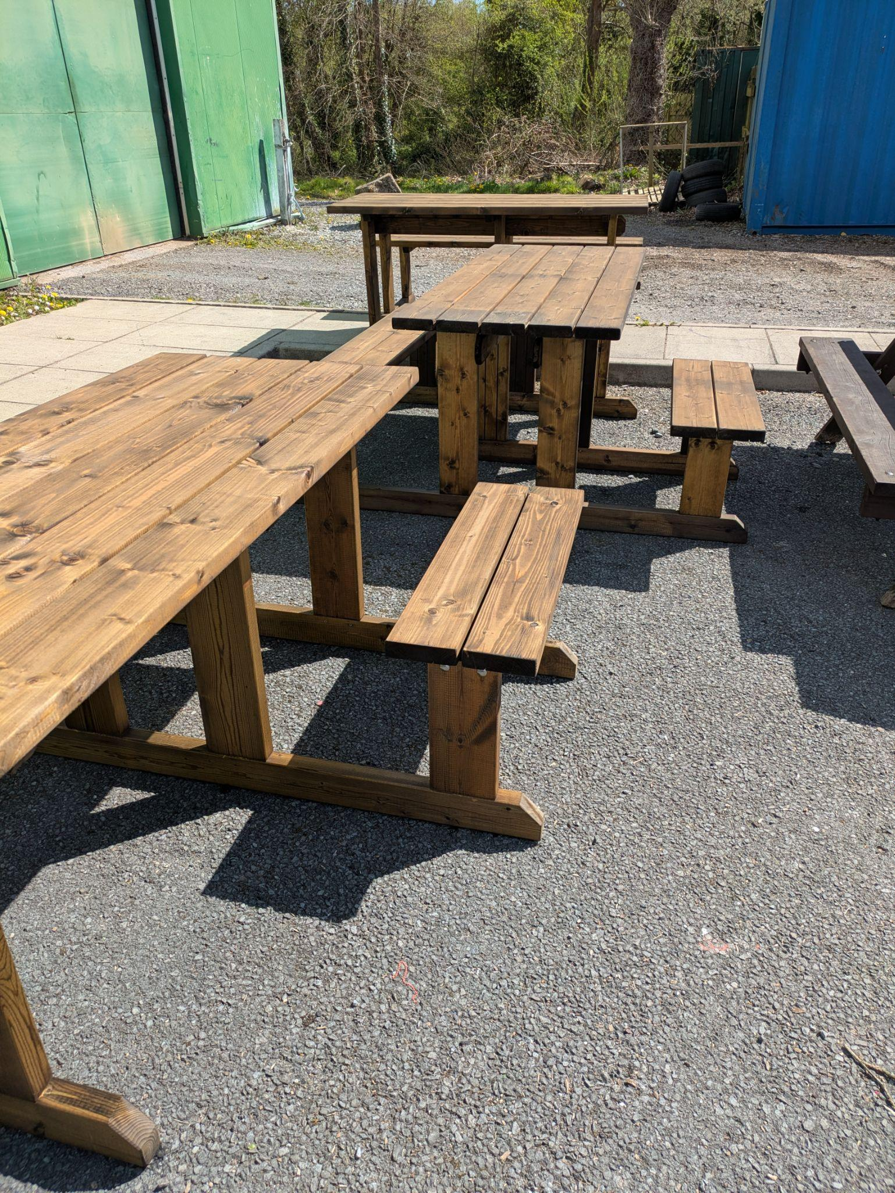
We have three accessible wooden picnic benches. They each feature a space for one wheelchair which allows wheelchair users to sit comfortably alongside their groups.The benches are positioned outdoors to support inclusive dining, socialising, and rest breaks. In the summer, we have a picnic bench outside our Village Cafe.

Dining & Catering
Dining facilities aim to cater for a wide range of dietary and accessibility requirements.

Dietary Requirements
Please inform us in advance about:
- Allergies
- Intolerances
- Texture requirements
- Religious dietary requirements
- Vegetarian or vegan diets
We can provide pureed meals if given advance notice.

Dining Area Accessibility
Dining areas include:
- Step-free access
- Seats that can be moved from the tables to accommodate wheelchair users
- Space for wheelchairs

Toilets & Changing Facilities
The toilet facilities across the site are all accessible.
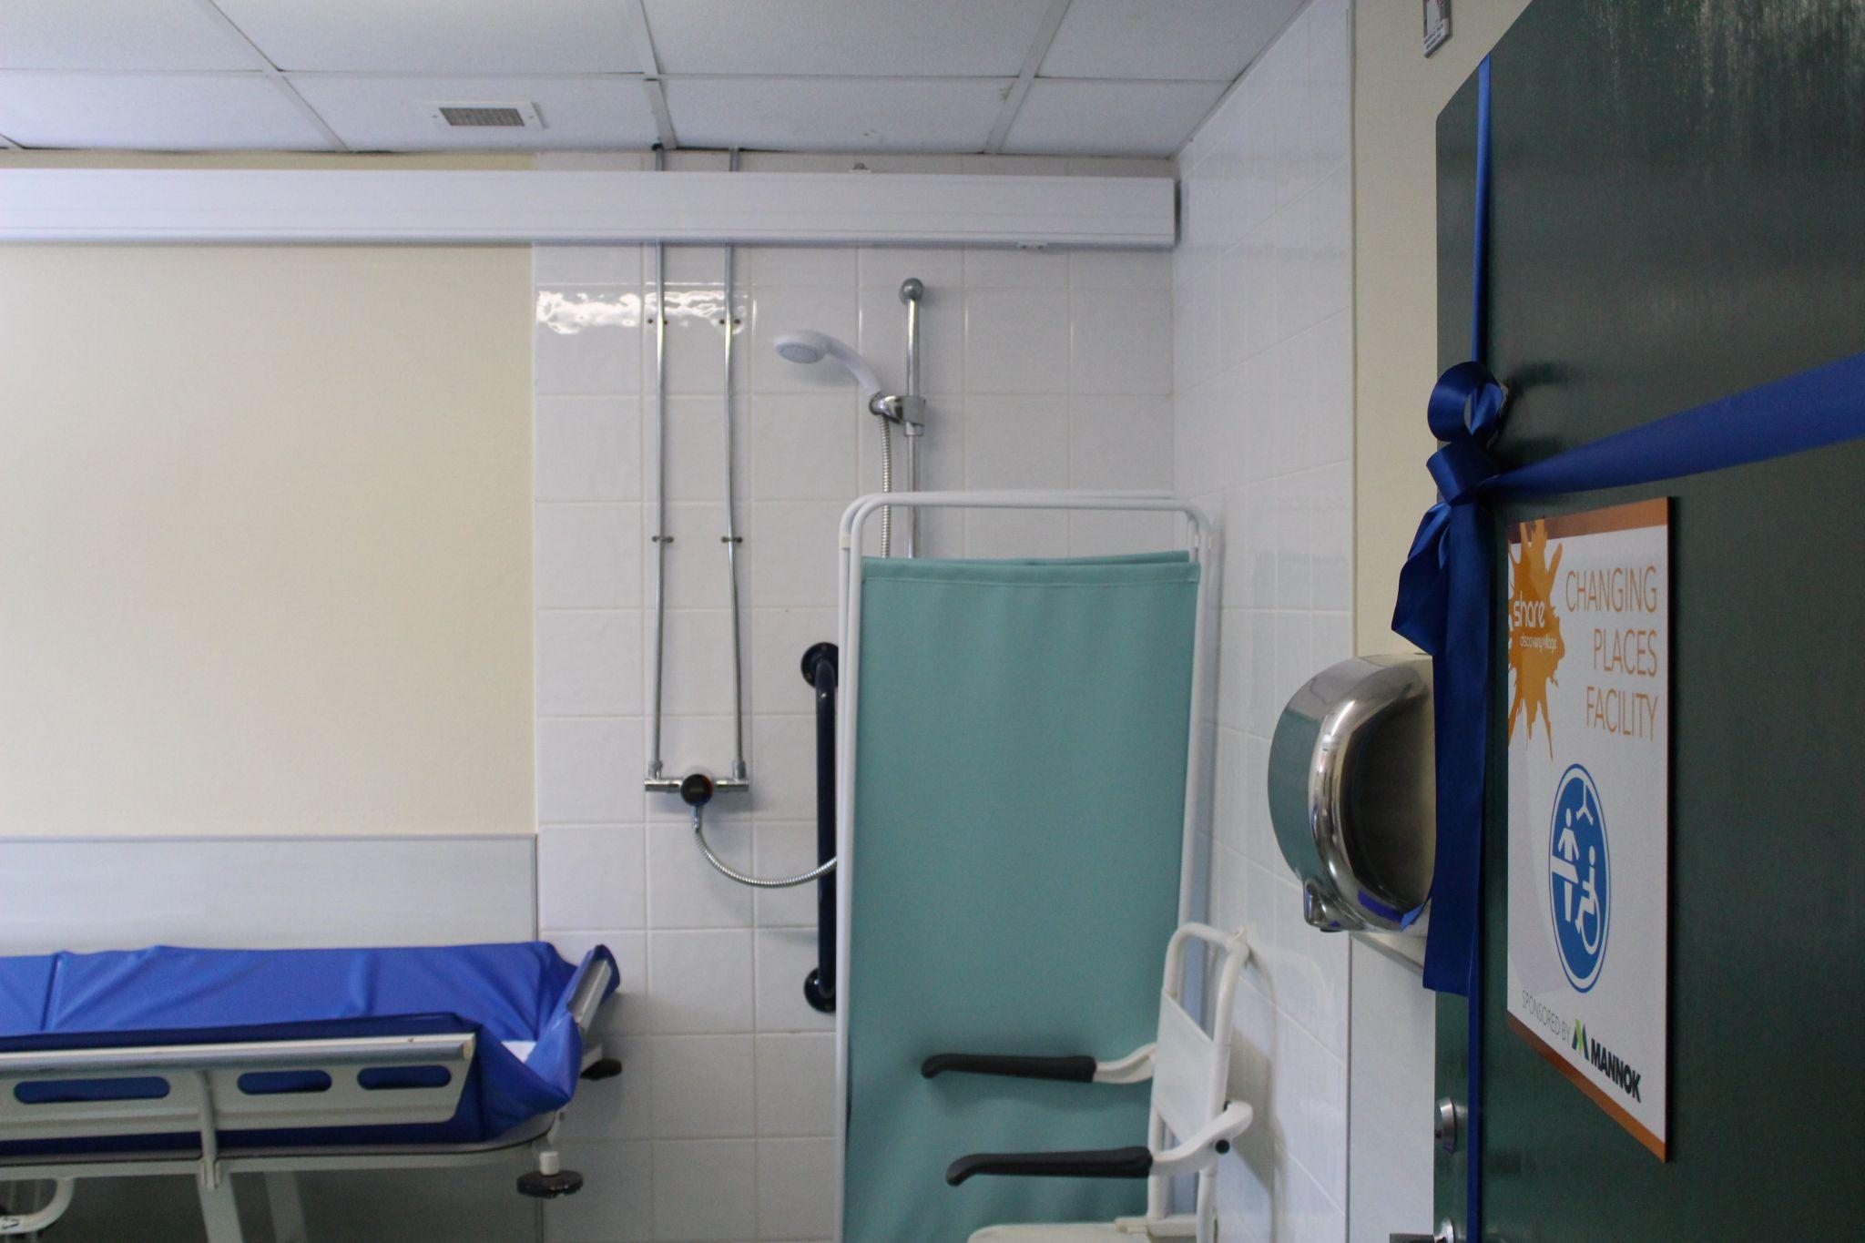
Facilities include:
- Grab rails
- Wheelchair turning space
- Accessible sinks
- Shower access
Our leisure suite has a Changing Places facility for guests who need an overhead hoist and a changing table.
Please contact us ahead of your visit for detailed information.
Sensory & Quiet Spaces
We understand that some guests may benefit from quieter environments but at times, some areas around our site may include:
- Loud noises during activities
- Crowded dining periods
- Outdoor environmental sounds
- Bright lighting in communal areas

Support Strategies
Where possible, we can:
- Identify quieter areas
- Discuss quieter times for activities
- Provide clear schedules
- Support gradual introductions to activities
Guests are welcome to bring personal sensory aids or comfort items.

Mobility & Site Navigation
We have a large outdoor site with varied terrain. Most of the site is accessible for wheelchair users.

Terrain Information
Areas around site may include:
- Tarmac paths
- Gravel surfaces
- Grass areas
- Hills and slopes
- Woodland trails
Some activity areas may require travel over uneven ground.

Wheelchair Users
Certain areas are wheelchair accessible, while others may have limited access due to terrain or safety restrictions.
Please contact us in advance to discuss specific routes and facilities.

Medical & Additional Support

Medication
Guests are responsible for bringing required medication.

Group leaders should ensure:
- Medication is clearly labelled
- Emergency medication is accessible
- Relevant staff are informed where appropriate

First Aid
Trained staff and first aid support are available on site.
Emergency procedures are in place for activities and accommodation areas.

Personal Care Support
Guests requiring personal care support should attend with appropriate carers or support staff where needed.

Assistance Dogs
Assistance dogs are welcome at Share Discovery Village and may stay at no additional charge on our campsite, in our self-catering chalets, and in three of our glamping pods (Deer, Fox and Rabbit). For further information, please see our pet policy at www.sharevillage.org/pet-policy.
Owners or handlers remain responsible for the care and supervision of their assistance dogs throughout their visit. If you have any specific requirements or would like to discuss your stay in advance, please contact us and we will be happy to help.
Emergency Procedures
Emergency procedures are in place across the site.
In an Emergency
Guests should:
- Follow staff instructions
- Proceed to designated assembly points
- Inform staff if additional assistance is required
- Tell staff if they or another member of their booking become ill or phone emergency services if necessary

Evacuation Support
We encourage guests and group leaders to inform us of any evacuation support requirements before arrival.
Group Leaders & Schools
We ask schools and group leaders to discuss accessibility needs with our team before visiting.
Useful information to provide includes:
- Participant support needs
- Mobility requirements
- Medical information
- Staffing ratios
- Behaviour support requirements
- Communication needs
Pre-visits may be available by arrangement.

Accessibility Contacts
For accessibility enquiries or support planning, please contact:

General Enquiries
Phone: +44 (0) 28 677 22122
Email: info@sharevillage.org
Website: www.sharevillage.org

Postal Address:
221 Lisnaskea Road,
Lisnaskea,
Co. Fermanagh,
BT92 0JZ
Northern Ireland

Feedback & Continuous Improvement
We are committed to improving accessibility across our facilities and services.
We welcome feedback from guests, carers, schools, and organisations to help us improve future experiences. If you have suggestions or accessibility feedback, please contact our team. Our contact information is in our contacts section on the previous page.

Thank you for choosing Share Discovery Village. We look forward to welcoming you!

